For Immediate Release
March 16, 2015

Media Contact: Connie Fauber, Chairman SVLM
540-436-3449
shenandoahlutheran@gmail.com

SHENANDOAH VALLEY LUTHERAN MINISTRIES IS PLEASED TO ANNOUNCE THE ADDITION OF A FAITH COMMUNITY NURSE TO THEIR OUTREACH MINISTRIES
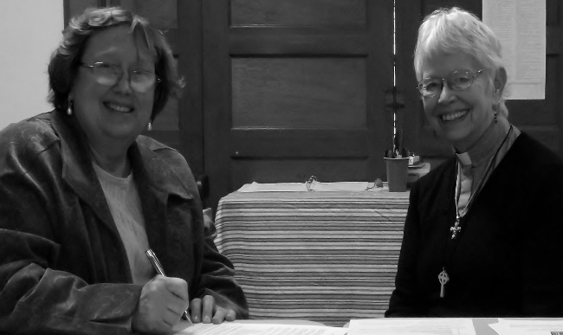
Shenandoah Valley Lutheran Ministries, in conjunction with the Shenandoah County Health Ministry Coalition, is pleased to announce the selection of Jeannie Coffman, RN as our first Faith Community Nurse to serve selected congregations throughout Shenandoah County. This part time position is funded by a grant received from National Lutheran Communities and Services.
Pastor Mary Louise Brown, chairperson of the Shenandoah Valley Health Coalition, looks on as Jean Coffman signs her contract.
Ms. Coffman brings 34 years of health care nursing experience with her to this new position.
She was a nurse for 17 years at Shenandoah County Memorial Hospital before moving to Valley Health Systems for 17 years. Ms. Coffman received a BA degree in English for Wheeling Jesuit College in 1973 and her BSN in nursing in 1979 from Radford University. She is currently enrolled in the Foundations of Faith Community Nursing at Shenandoah University.

Ms. Coffman is a member of St. Paul Lutheran Church in Jerome where she has been involved in many church activities over the years. So in addition to her nursing experience she has a great knowledge of Shenandoah County and its residents. She has two children, John a resident of Shenandoah County and Rebecca who lives in Texas, and four grandchildren.

When asked about being on the ground floor of developing this new position of Faith Community Nurse who will serve a number congregations rather than just one congregation she said, “I am very excited and somewhat overwhelmed at the same time! I look forward to using this call to serve God and my community in this way.” Faith Community Nursing is a wholistic approach to care with the nurse caring for the body, mind and spirit of an individual.
Ms. Coffman will be instrumental in developing this part-time position into a program that will have additional Faith Community Nurses serving more congregations throughout our county. Shenandoah Valley Lutheran Ministries looks forward to helping this program to grow and serve many people throughout Shenandoah County in the coming years.

